

|  |
| --- |
| Zedra  Azure Devops - Visual Studio |
| Scope: Non-Zedra Users Guide for the External Collaboration Platform  Project Manager: Jack Boolcock  Author: Irimie Razvan  Code Version Control Training Guide |



Version: 1.0

Date: 09.28.2020

#### ABOUT THIS DOCUMENT

* 1. **Document control:**

|  |  |  |  |
| --- | --- | --- | --- |
| Version | Date | Changed By | Purpose of revision |
| 1.0 | 09.28.2020 | Razvan Irimie | Created Document |
|  |  |  |  |
|  |  |  |  |

* 1. **About:**

Azure DevOps is a Software as a service (SaaS) platform from Microsoft that provides an end-to-end DevOps toolchain for developing and deploying software.

Azure DevOps provides an exhaustive range of services such as:

* **Azure** **Boards**: agile planning, work item tracking, visualization and reporting tool.
* **Azure** **Pipelines**: cloud CI/CD platform
* **Azure** **Repos**: provides cloud-hosted private git repos
* **Azure** **Artifacts**: provides integrated package management with support for Maven, Python and NuGet package feeds from public or private sources.

This document focuses on **Azure Repos**, which allows teams of developers to store, collaborate and review code and applications. History is maintained for all changes, including any conflicts resolution, if multiple developers work on the same file.

* 1. **Objective:**

The objective of this document is:

* To provide appropriate training and guidance for Zedra Staff on how to work and collaborate on code using Azure DevOps

#### INITIAL SET-UP

* In order to work with **Azure** **DevOps**, developers must use the **Visual** **Studio** **IDE** (Integrated Development Environment).
  1. **Download and Install Visual Studio:**
     + Navigate to the [Visual Studio Website](https://visualstudio.microsoft.com/) and download the appropriate version of Visual Studio (See details regarding different Visual Studio Version [here](https://visualstudio.microsoft.com/vs/compare/)). For this document we will use **Visual Studio – Community Edition**

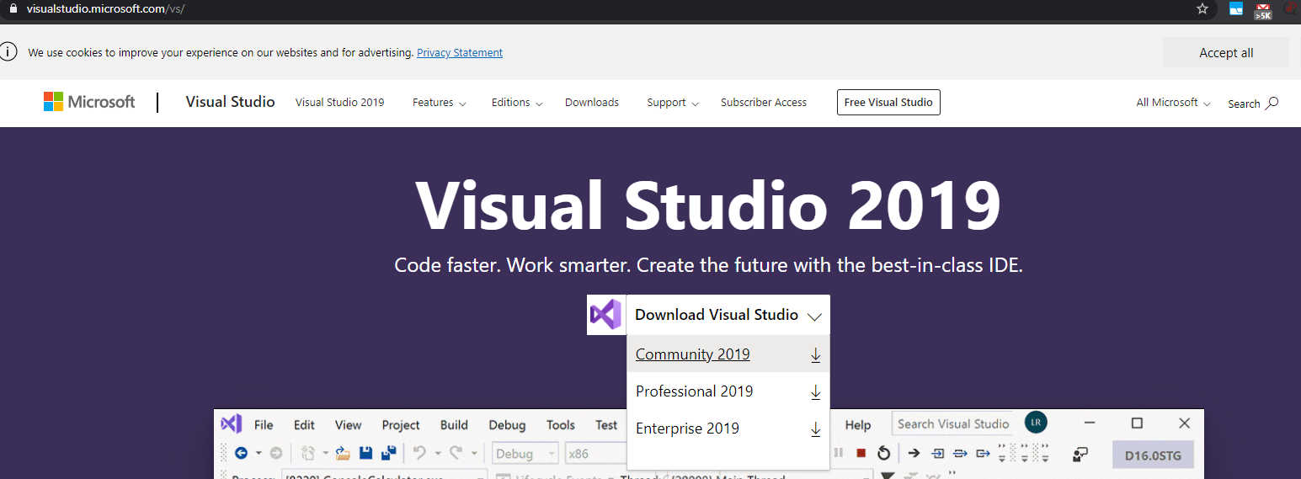

* + - Go through the installation steps and once the dependencies have been downloaded, you will be greeted with the following window. Select the three modules listed below

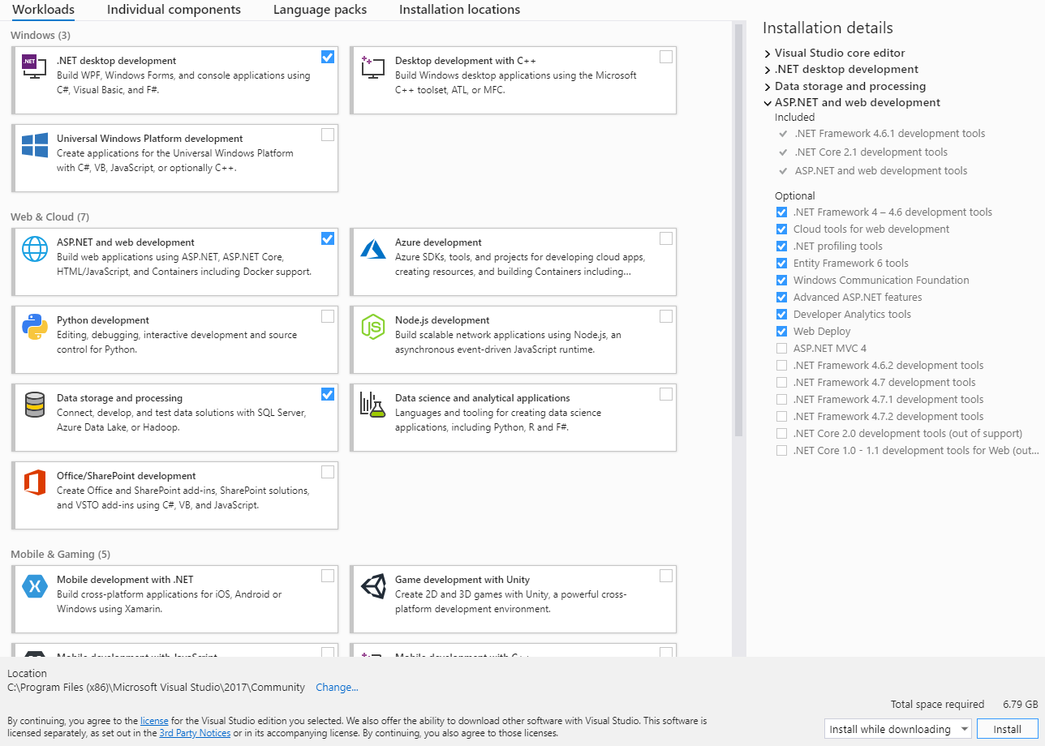

* + - After you selected the desired modules, select Install

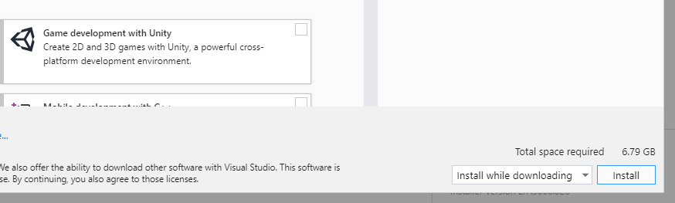

* + - **Visual Studio** IDE will launch after the installer has finished.
    - 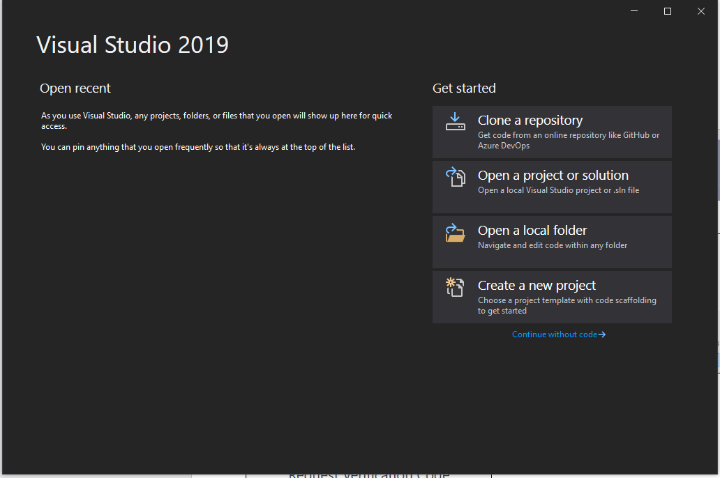From the Welcome window, select **Clone a Repository**
    - Select Azure DevOps, from the **Browse a repository** section
    - Select **Sign In** from the Connect to a project window
    - Input your credentials and go through the two- factor authentication process

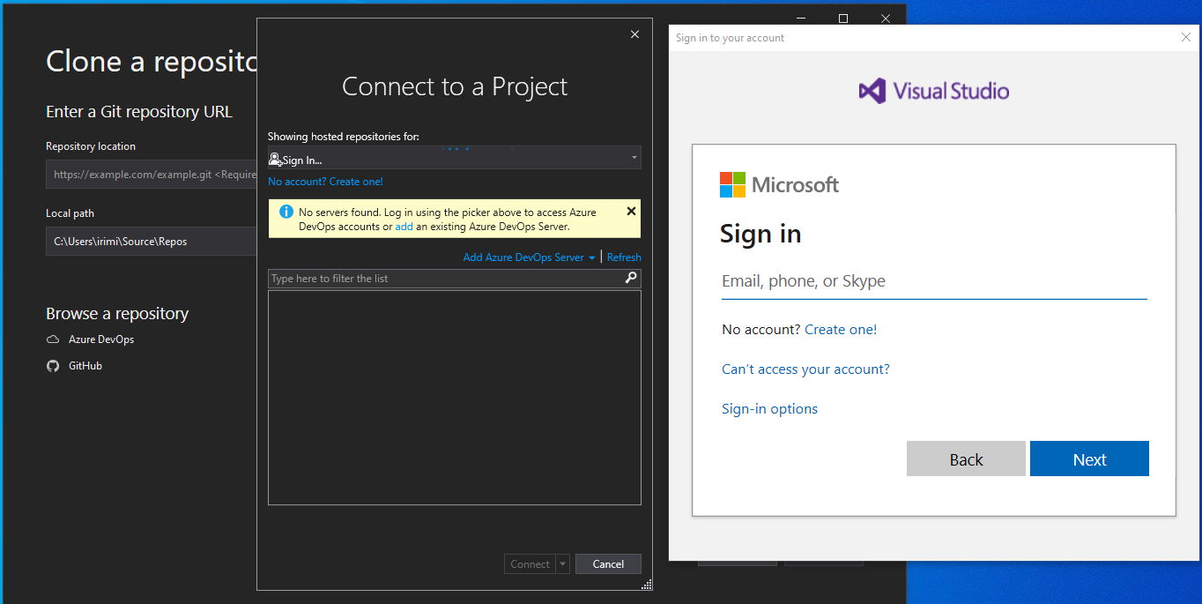

* + - You will be prompted to select the repository from the list of repositories stored in Zedra Azure DevOps

#### COLLABORATE

1. After you verify the **Authentication** **code**, you will be directed to the following window, which allows you to upload documents and entire folders or create folders so that you can customize the structure of the project.

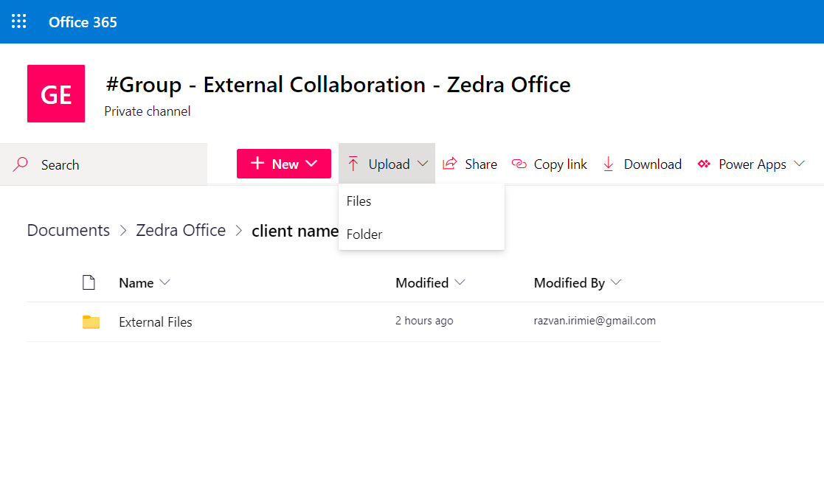Upload Files/folders:

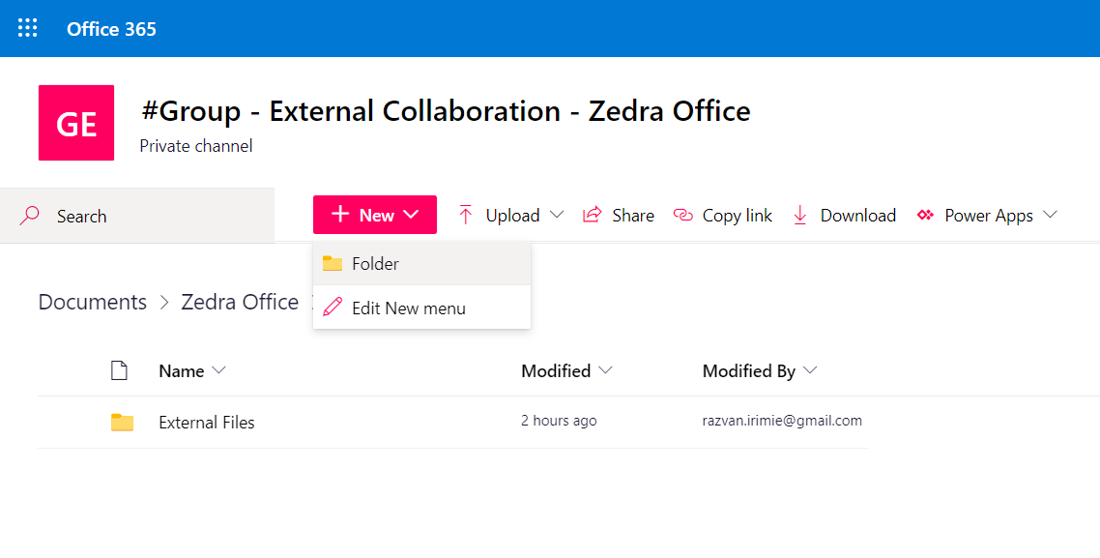  
Create Folders

1. Users can also upload files by “dragging” the files in the appropriate folder, from your machine:

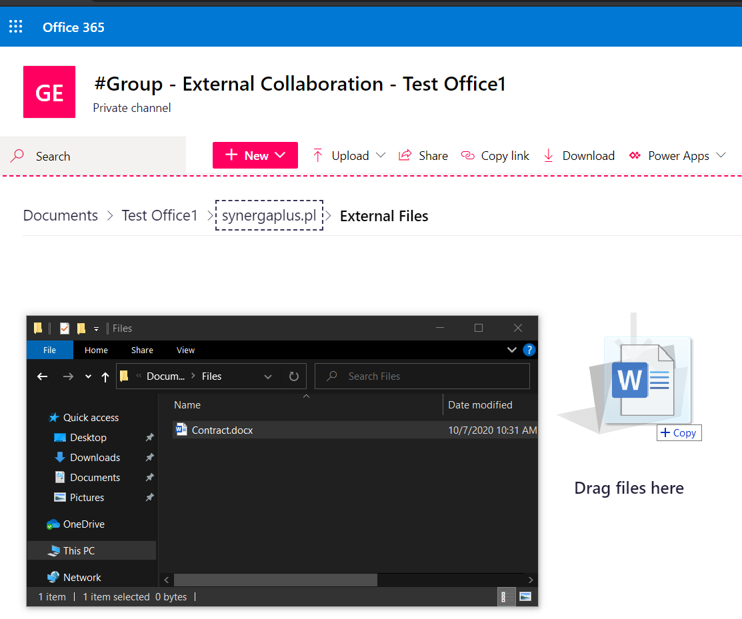

#### MANAGE CONTENT

Users have an extensive list of options when it comes to managing documents:

* In order to edit the document users can either:
  + Use the “Open in browser” option which will open the document in a new tab, in a Web Version of Microsoft Word.

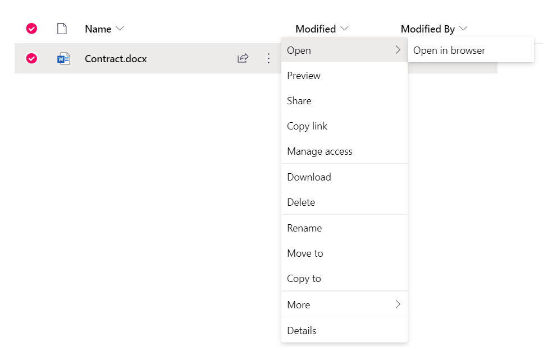

* + Download the document, edit it on their device and afterwards upload it back to the platform (see **section 3. Collaborate** for instructions on how to upload content).

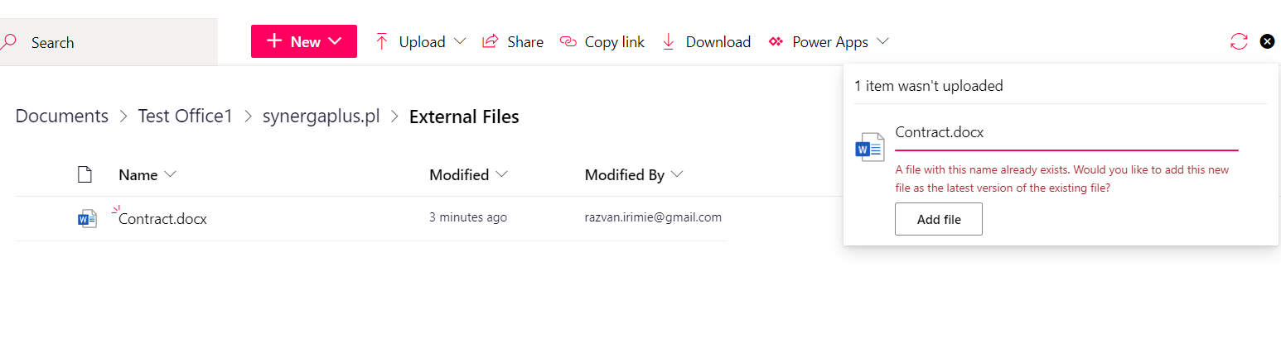

**!NOTE**: If the uploaded file has the same name as an already existing file on the platform users ill receive a prompt asking them to confirm if they would like to upload the file as a version of the existing file.

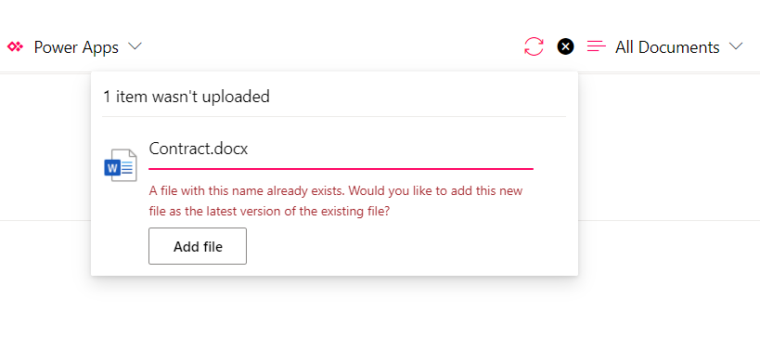

**For any further questions or inquiries please contact the Zedra Service Desk via email at** [**Servicedesk@zedra.com**](mailto:servicedesk@zedra.com?subject=External%20Collaboration%20Platform%20Assistance)